Mid Term Proposal

Contents

Descriptions: 2

Site Map 3

Data Model 4

Home Page 5

Cart Page 6

User Page 7

Browse Products Page 8

Product Details Page 9

# Descriptions:

These days it is especially difficult to dabble in the occult. One may visit a local mystic only to find crystals and candles. Another is forced to meet an individual of ill repute to purchase a particular tome of forbidden knowledge, only to be stabbed in the back by the scoundrel! In these trying times fear not! Madame Angelique’s Occult and Esoteric Emporium is an online e-commerce site for the seekers of the arcane unknown. Whether you are a member of the of a Hermetic Order communing with an Old One or a grave digger with an extracurricular activity that is best performed by moonlight, Madame Angelique’s Occult and Esoteric Emporium has you covered. We also carry a fine assortment of lamps and other décor to make your séance room feel cozy. Users simply create an account and shop to their hearts delight. A handy search bar can help users find what they are after, or they can window shop through our various categories. Worried that the copy of The Necronomicon you are looking at is a knock off? Not to worry other customers can leave reviews of products and let other users know. Once a customer finds a must have item, they can add it to their cart and then checkout (credit card required, no checks, cash, or IOUs.)

# Site Map

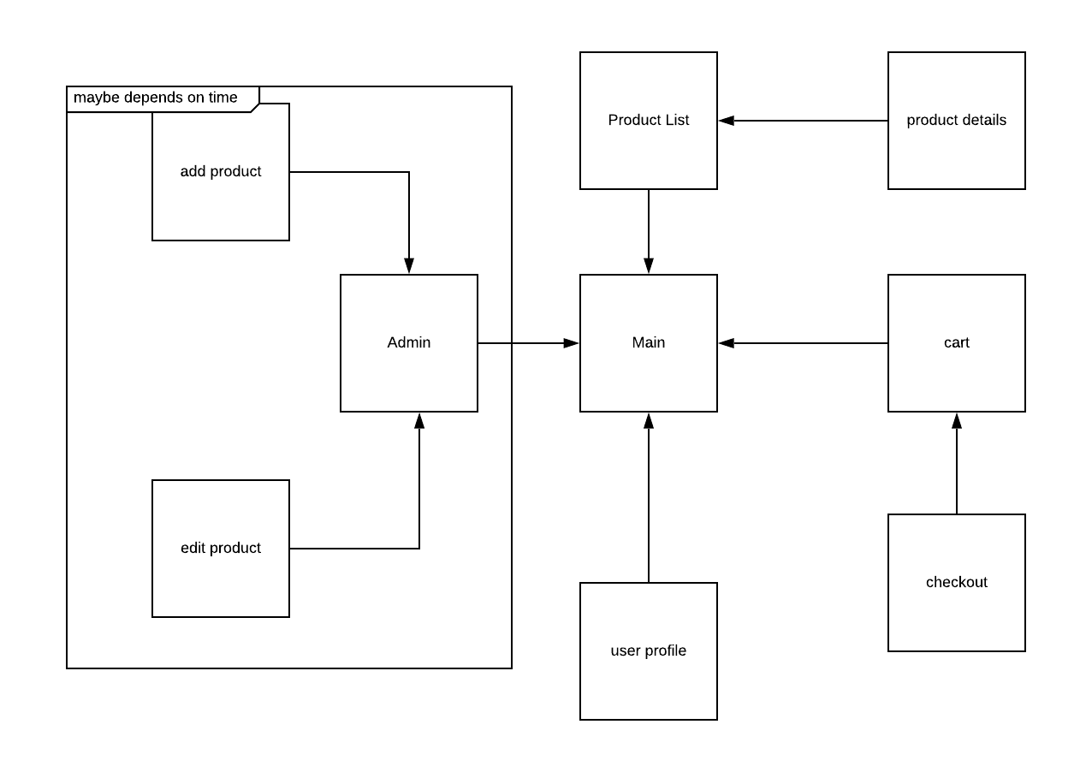

# Data Model

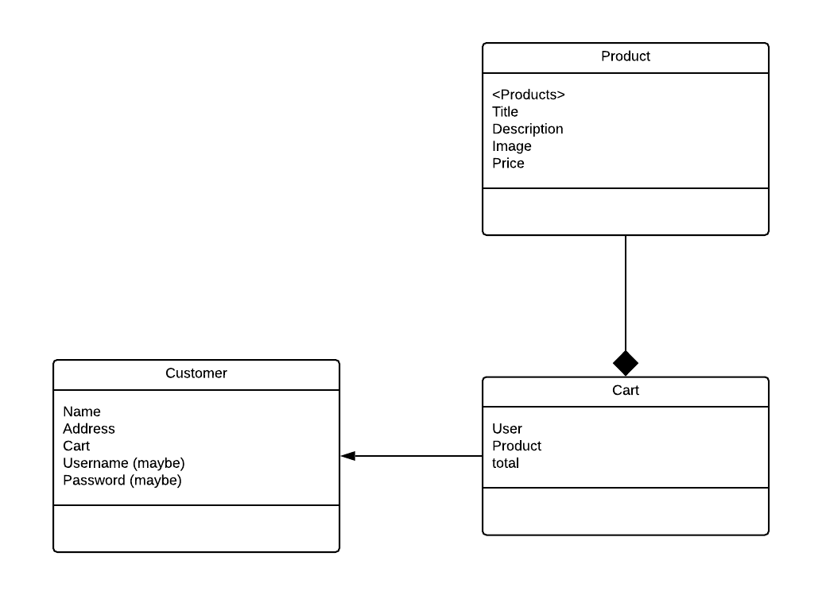

# Home Page

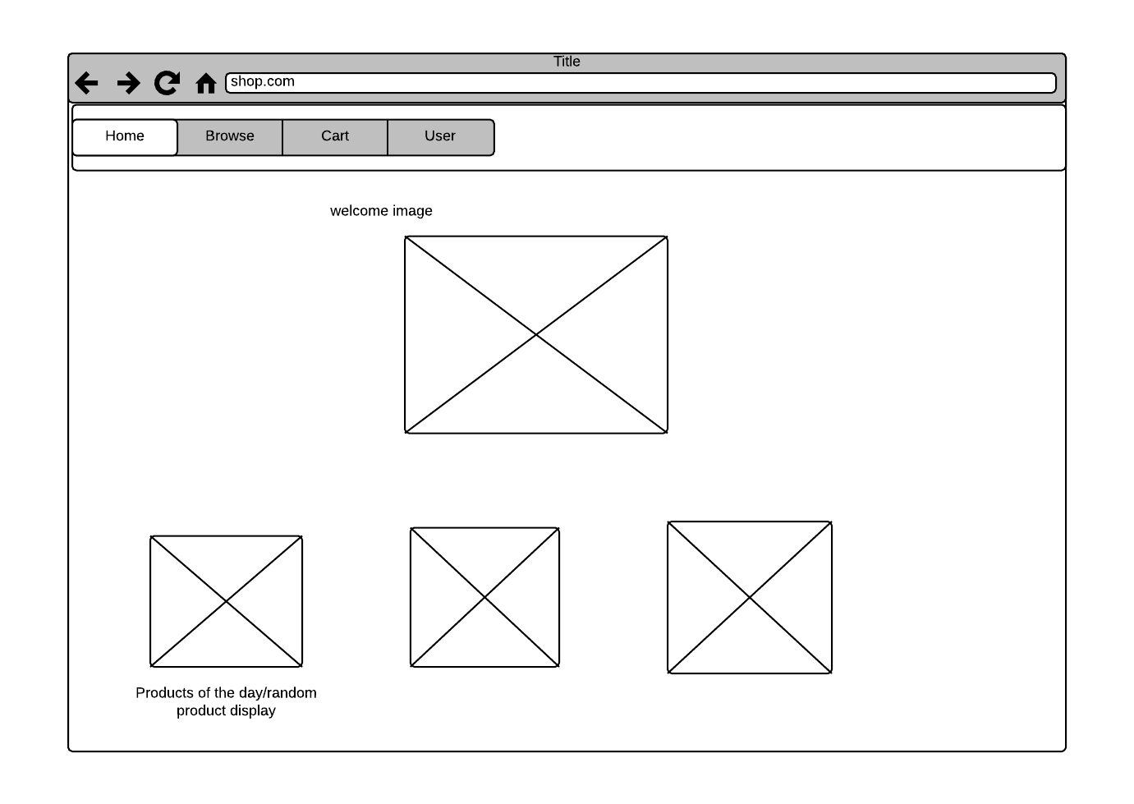

# Cart Page

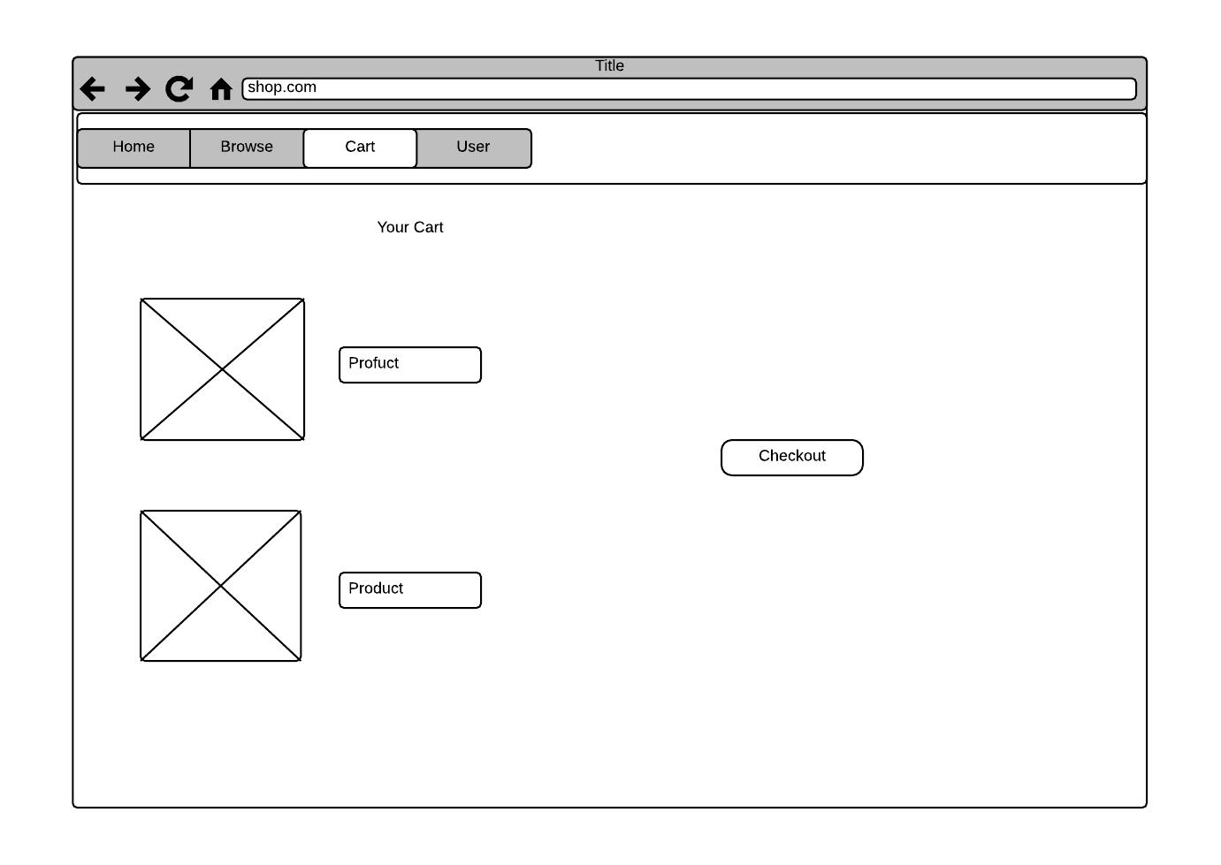

# User Page

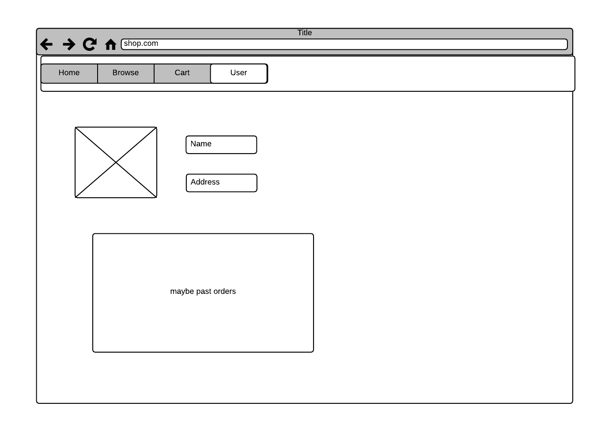

# Browse Products Page

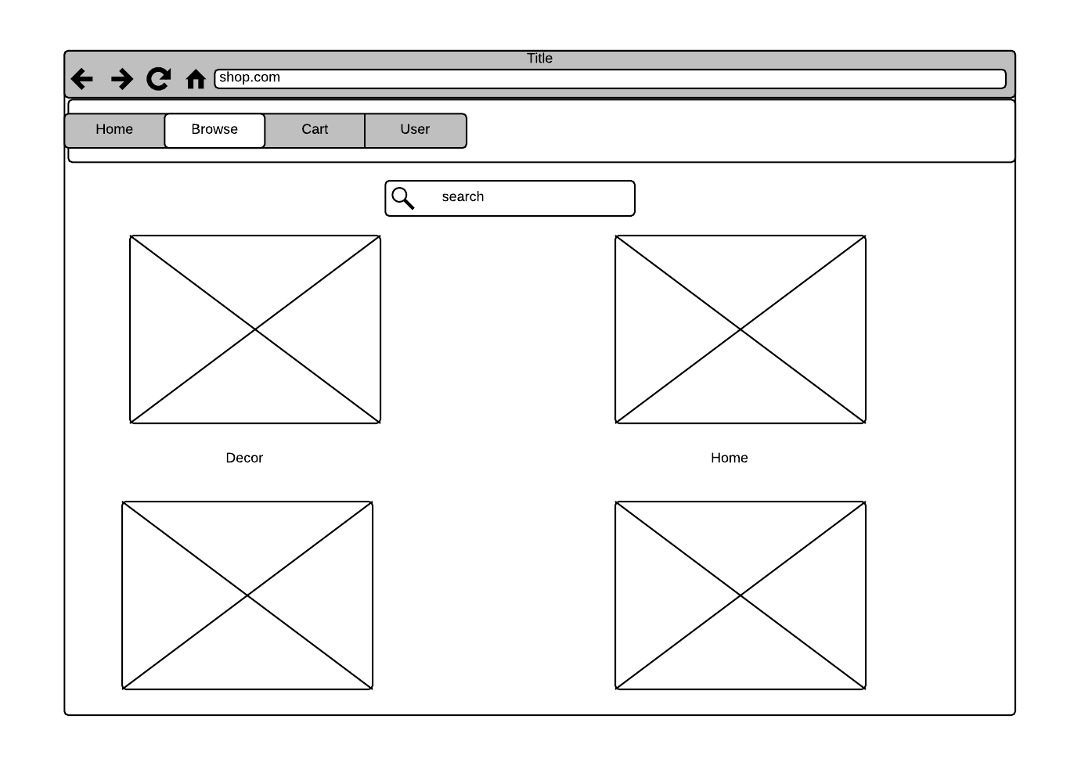

# Product Details Page

